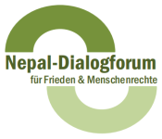

Registration Form

Nepal Dialogue Forum Conference 2017
Overcoming Discrimination and Marginalisation in Nepal
Strategic Approaches for Human Rights and Peacebuilding

30 March 2017 (10.30am-6pm) / 31 March 2017 (9am-1.30pm) in Berlin/Germany
Bread for the World – Protestant Development Service, Caroline-Michaelis-Str. 1, 10115 Berlin

Name
Organisation

Address

Tel.
Email

I would like to stay for dinner on 30 March 2017 _____ yes ______ no
I would like to stay for lunch on 31 March 2017 _____ yes ______ no

Meals will be vegetarian.

Please register by mail or post by 21 February 2017
Nepal Dialogue Forum
Greifswalder Str.4
10405 Berlin, GERMANY
Tel.: +49-30-88766956
Email: koordination@nepal-dialogforum.de

